80% Vaccination Uptake

Population-wise projections

Cervical Cancer Incidence
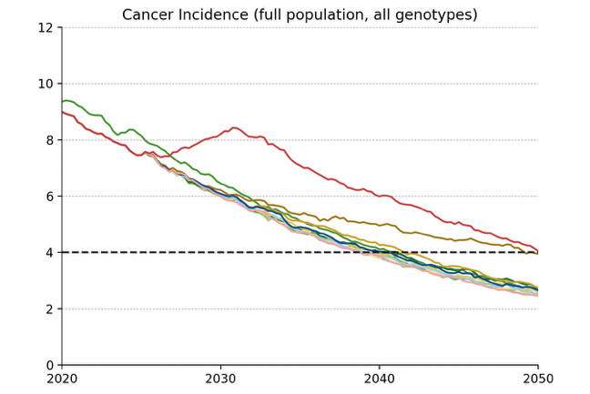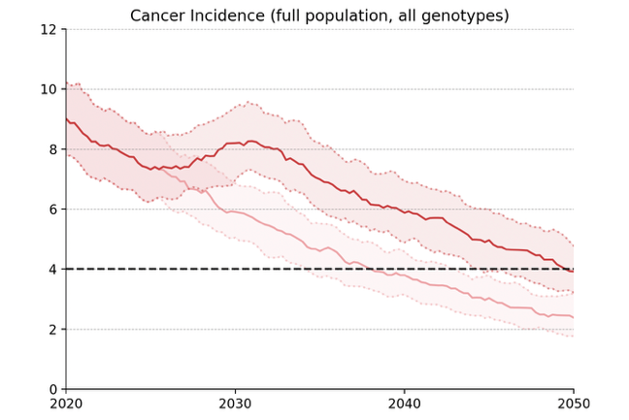
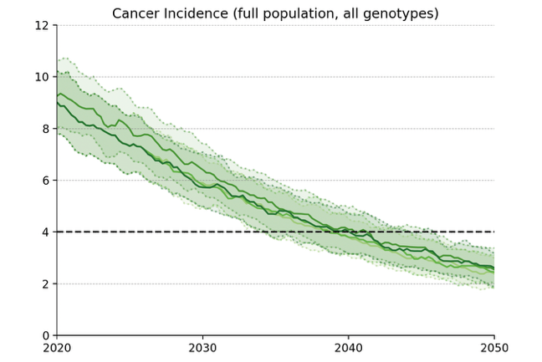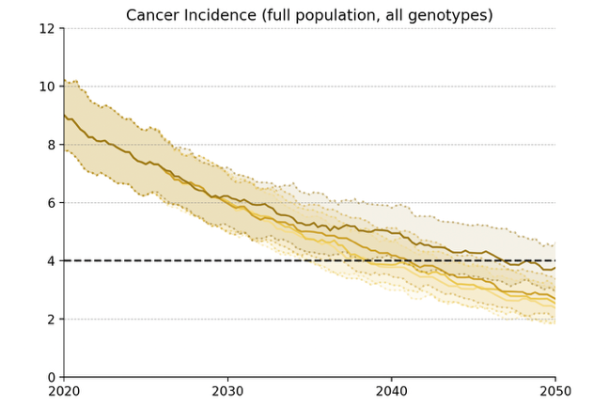
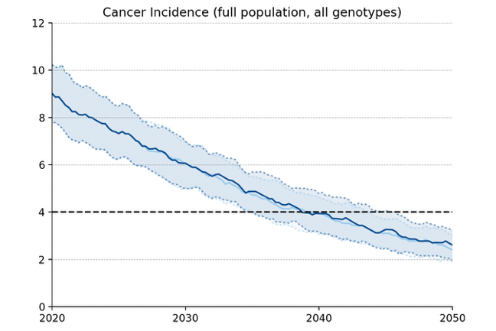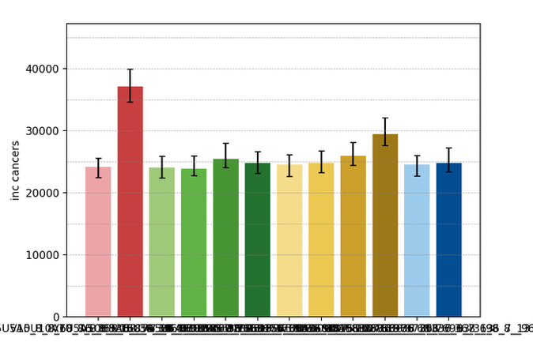
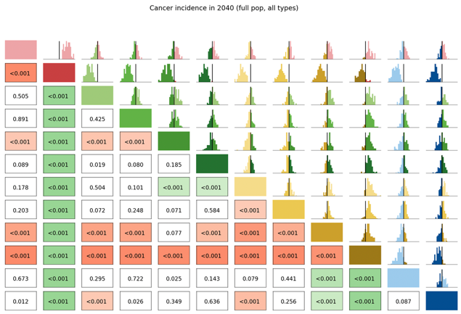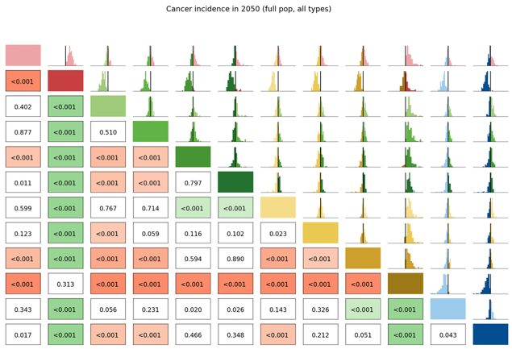

Long Term Undiagnosed Prevalence
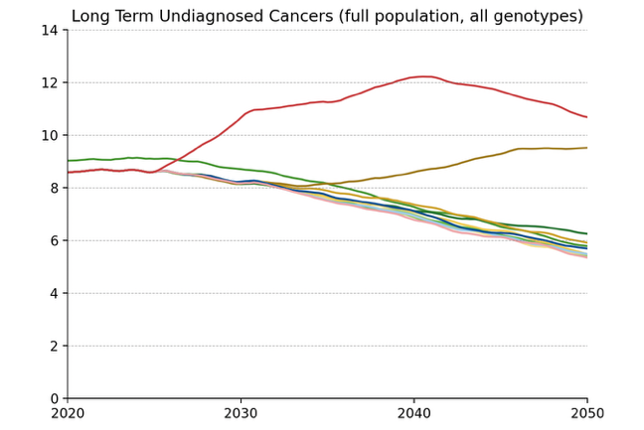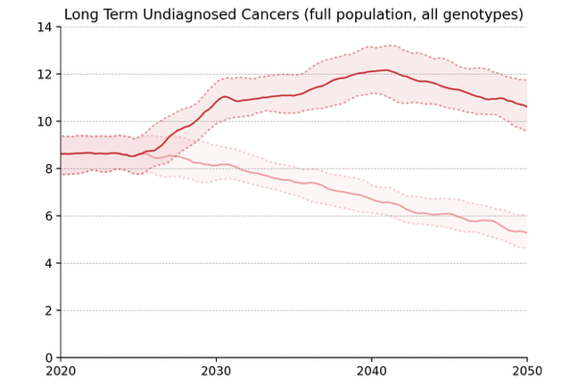
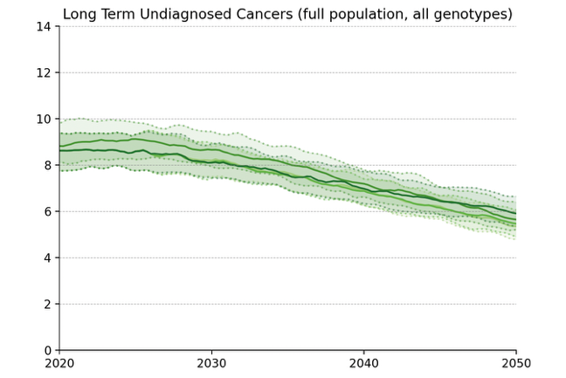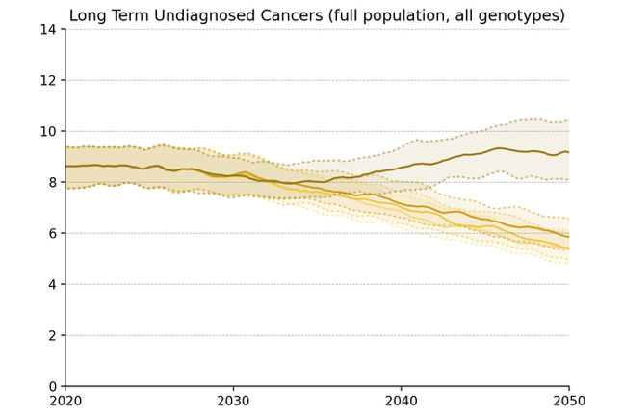
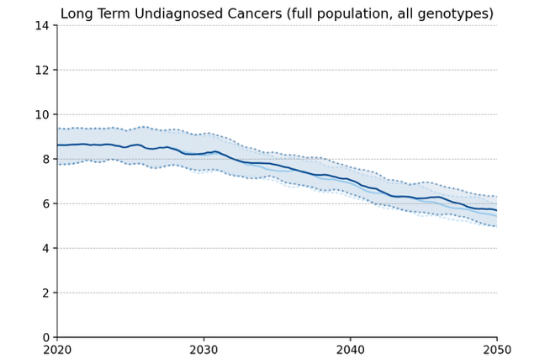
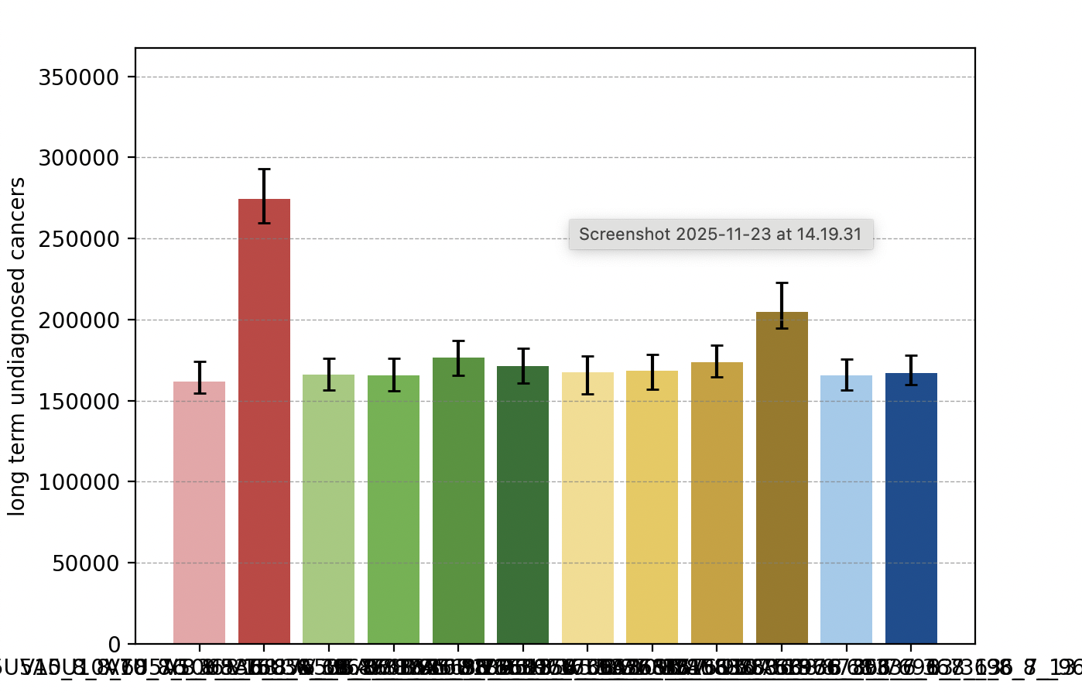
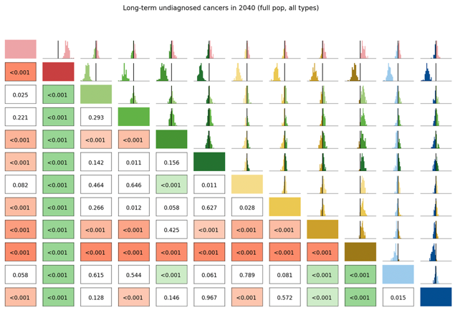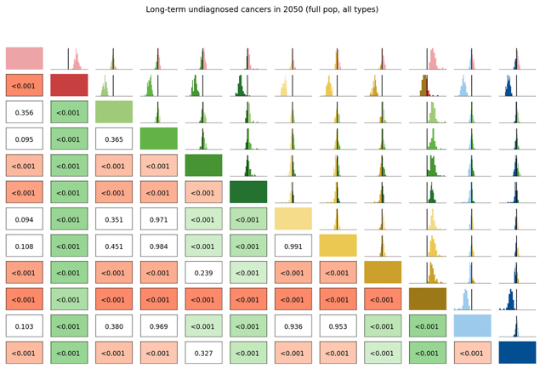

Number of Routine Screens
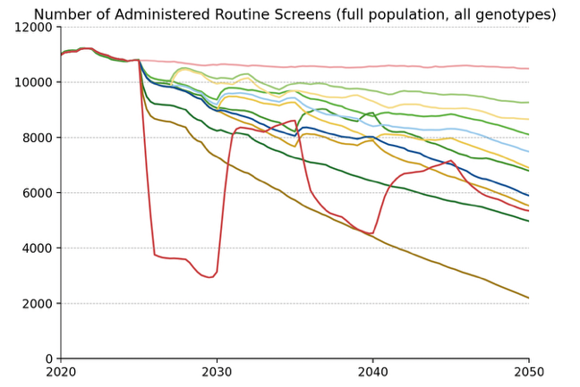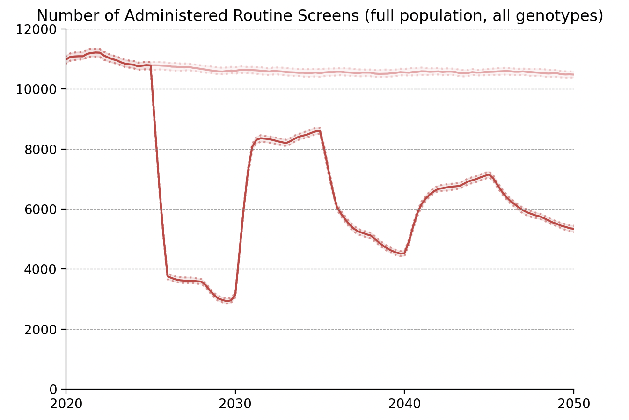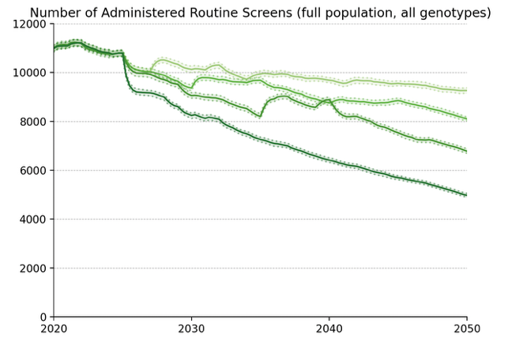
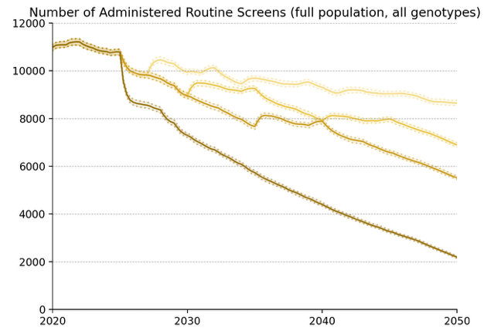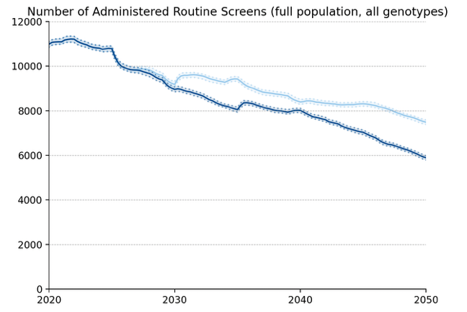
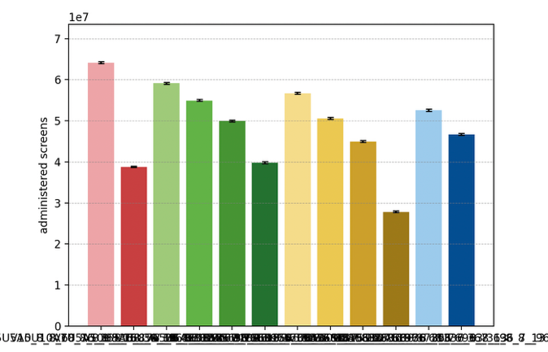

Average Number of Screens per Diagnosed Cancer, 2030-50
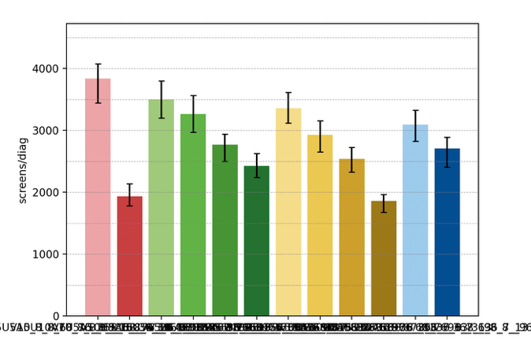

Elimination Probability Table
alg | Elimination Year: Median [LQ, UQ] (_8) | 2040.25 Elimination Probability (_8) | 2050.25 Elimination Probability (_8)
V5U5A5 | 2042 [2040, 2044] | 0.303 | 0.970
V7U5A5 | 2042 [2040, 2045] | 0.262 | 0.981
V10U5A5 | 2042 [2041, 2045] | 0.212 | 0.950
V15U5A5 | 2044 [2042, 2046] | 0.110 | 0.900
V_U5A5 | 2044 [2041, 2046] | 0.212 | 0.900
V7U7A5 | 2043 [2040, 2045] | 0.242 | 0.950
V10U10A5 | 2042 [2041, 2044] | 0.191 | 0.920
V15U15A5 | 2044 [2043, 2047] | 0.100 | 0.890
V_U_A5 | 2053 [2050, 2055] | 0.019 | 0.313
V10U7A5 | 2043 [2041, 2045] | 0.161 | 0.930
V15U10A5 | 2044 [2041, 2046] | 0.181 | 0.910
V10U10A10 | 2053 [2051, 2054] | 0.019 | 0.202
Maximum margin: 0.09110238395721516

Vaccinated Population projections

Cervical Cancer Incidence
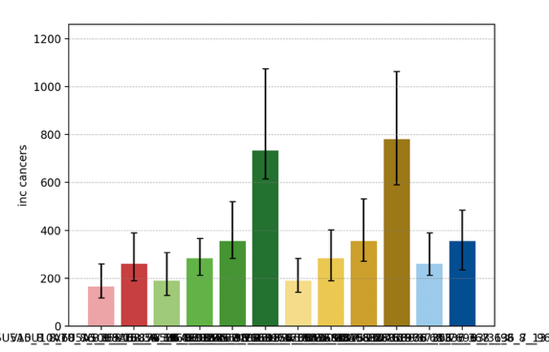
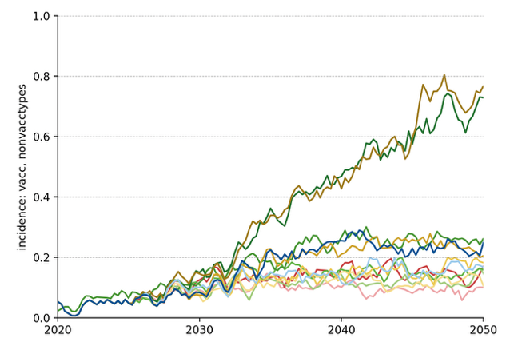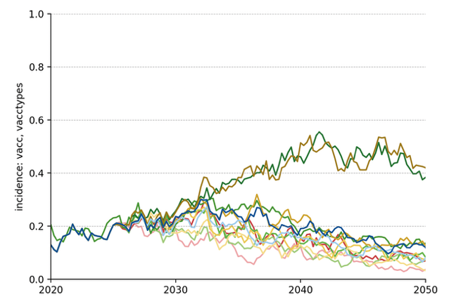
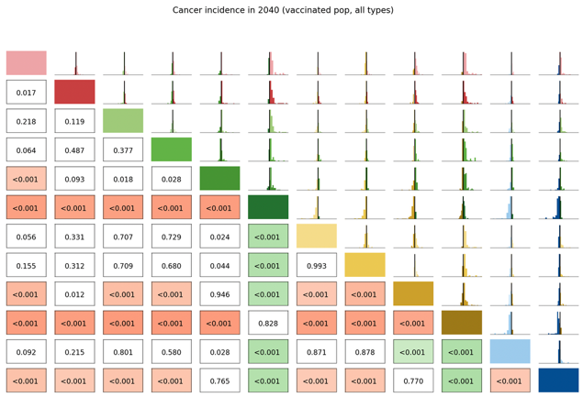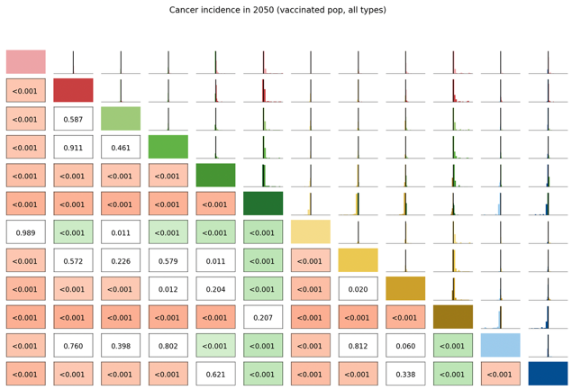

Long Term Undiagnosed Prevalence
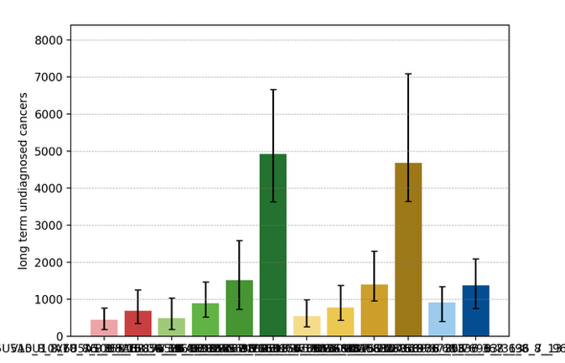
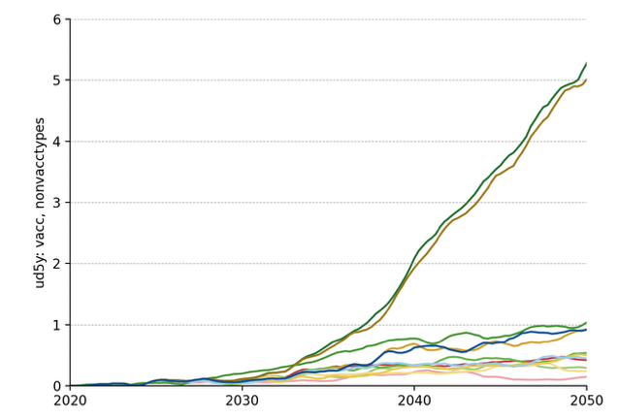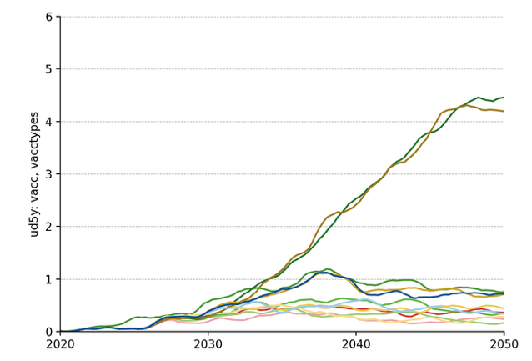
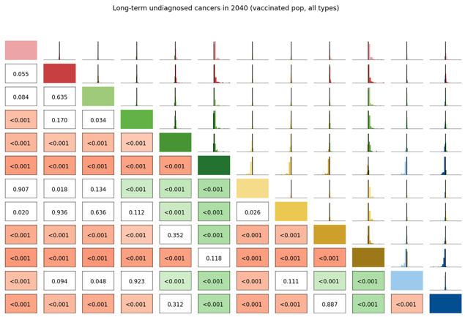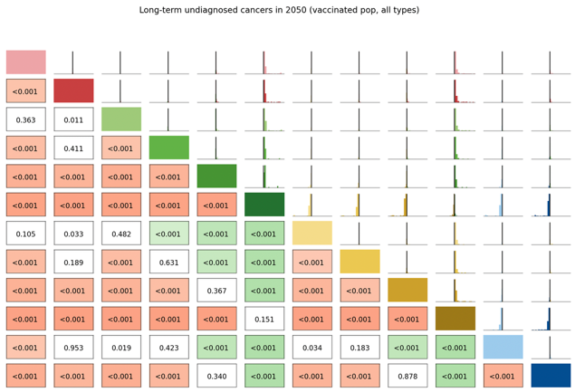

Number of Routine Screens
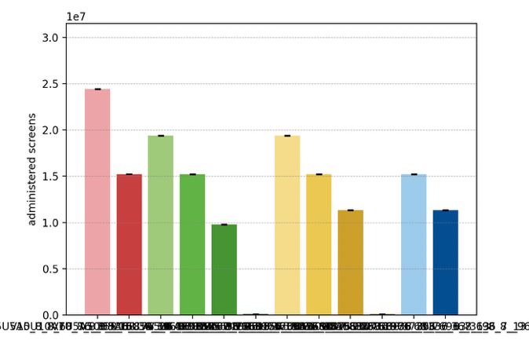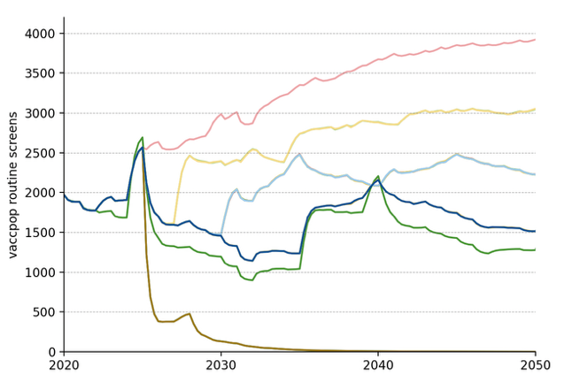

Average Number of Screens per Diagnosed Cancer, 2030-50
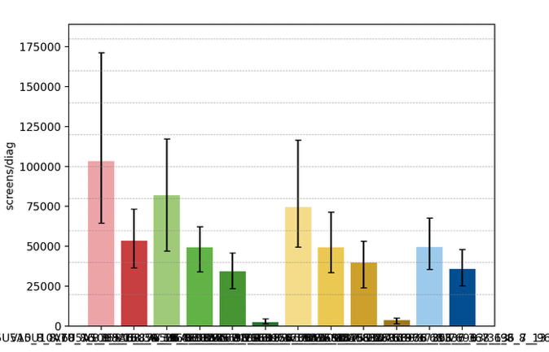

Elimination Probability Table
alg | Elimination Year: Median [LQ, UQ] (_8) | 2040.25 Elimination Probability (_8) | 2050.25 Elimination Probability (_8)
V5U5A5 | 2008 [2008, 2008] | 0.981 | 0.981
V7U5A5 | 2008 [2008, 2008] | 0.981 | 0.981
V10U5A5 | 2008 [2008, 2008] | 0.960 | 0.970
V15U5A5 | 2008 [2008, 2008] | 0.930 | 0.930
V_U5A5 | 2008 [2008, 2008] | 0.879 | 0.879
V7U7A5 | 2008 [2008, 2008] | 0.981 | 0.981
V10U10A5 | 2008 [2008, 2008] | 0.940 | 0.950
V15U15A5 | 2008 [2008, 2008] | 0.940 | 0.950
V_U_A5 | 2008 [2008, 2008] | 0.890 | 0.890
V10U7A5 | 2008 [2008, 2008] | 0.970 | 0.970
V15U10A5 | 2008 [2008, 2008] | 0.930 | 0.950
V10U10A10 | 2008 [2008, 2008] | 0.970 | 0.981
Maximum margin: 0.062416023198204884

Unvaccinated Vaccine Eligible Population projections

Cervical Cancer Incidence
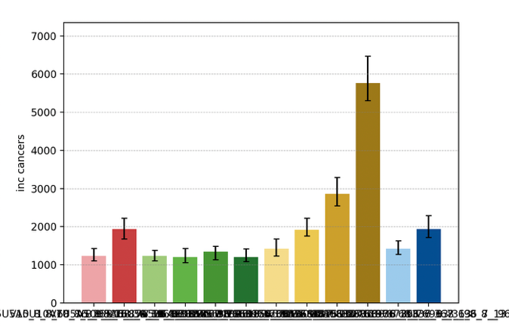
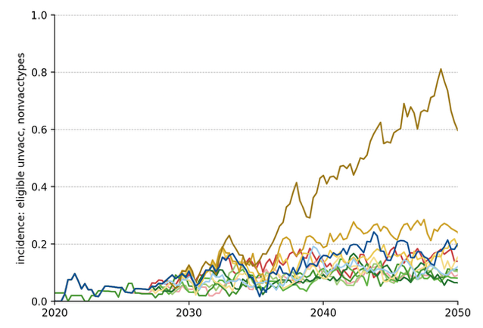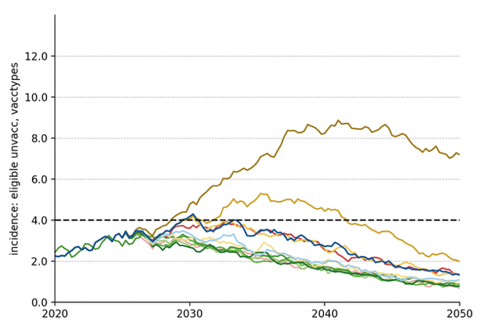
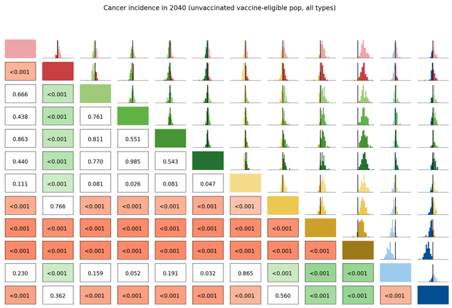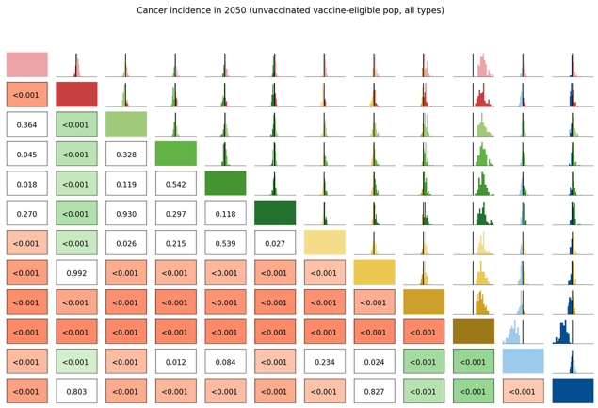

Long Term Undiagnosed Prevalence
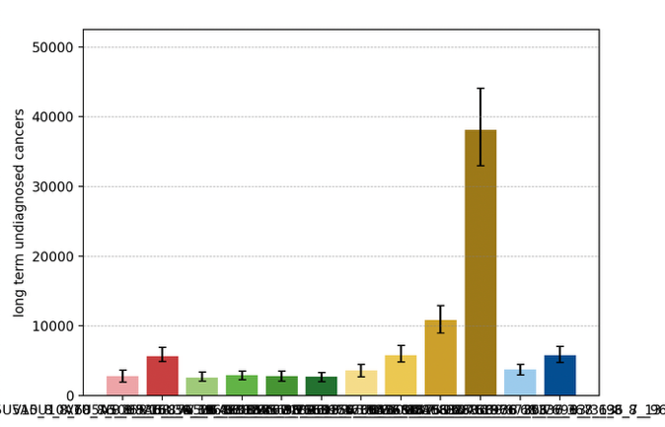
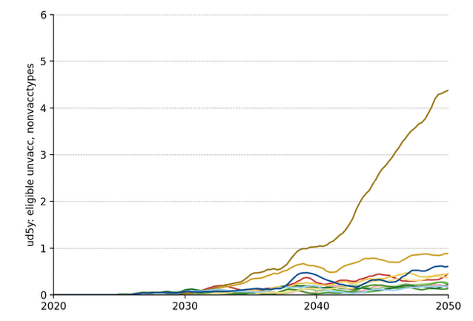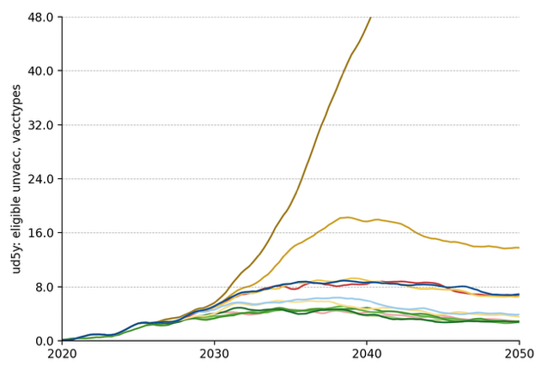

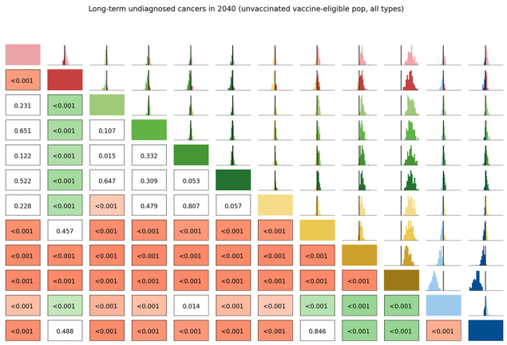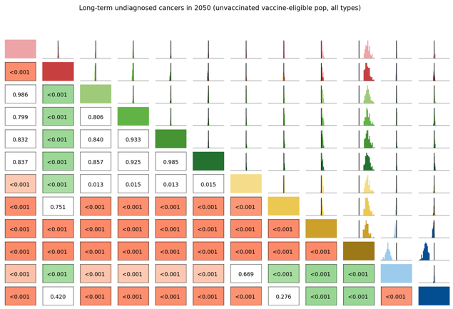

Number of Routine Screens
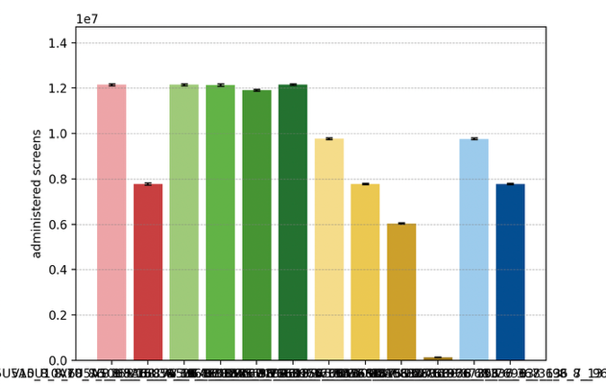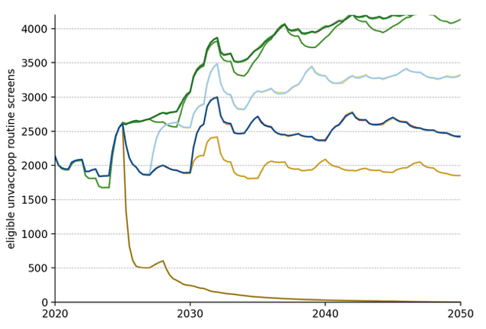

Average Number of Screens per Diagnosed Cancer, 2030-50
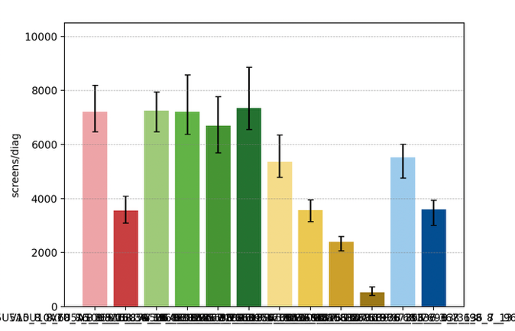

Elimination Probability Table
alg | Elimination Year: Median [LQ, UQ] (_8) | 2040.25 Elimination Probability (_8) | 2050.25 Elimination Probability (_8)
V5U5A5 | 2035 [2033, 2038] | 0.798 | 0.970
V7U5A5 | 2036 [2034, 2039] | 0.869 | 0.970
V10U5A5 | 2035 [2032, 2040] | 0.768 | 0.981
V15U5A5 | 2037 [2034, 2039] | 0.778 | 0.970
V_U5A5 | 2036 [2033, 2039] | 0.849 | 0.970
V7U7A5 | 2037 [2034, 2042] | 0.667 | 0.940
V10U10A5 | 2042 [2040, 2045] | 0.343 | 0.900
V15U15A5 | 2048 [2045, 2052] | 0.019 | 0.697
V_U_A5 | 2056 [2055, 2056] | 0.019 | 0.019
V10U7A5 | 2038 [2035, 2042] | 0.667 | 0.970
V15U10A5 | 2042 [2039, 2046] | 0.303 | 0.849
V10U10A10 | 2042 [2039, 2045] | 0.394 | 0.900
Maximum margin: 0.09622832138056549

